**Prompt from Canvas:**

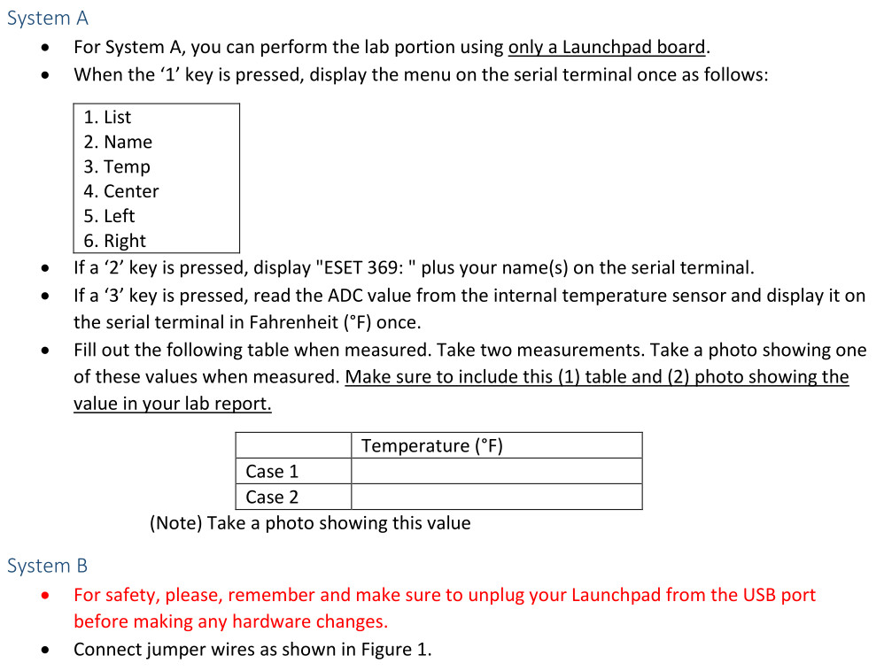

**Simplified prompt:**

System A

Students need to write a C/C++ program to do this.

For System A, you can perform the lab portion using only a Launchpad board.

When the ‘1’ key is pressed, display the menu on the serial terminal once as follows:

1. List

2. Name

3. Temp

4. Center

5. Left

6. Right

If a ‘2’ key is pressed, display "ESET 369: " plus your name(s) on the serial terminal.

If a ‘3’ key is pressed, read the ADC value from the internal temperature sensor and display it on the serial terminal in Fahrenheit (°F) once.

Fill out the following table when measured. Take two measurements. Take a photo showing one of these values when measured. Make sure to include this (1) table and (2) photo showing the value in your lab report.

Temperature (°F)

Case 1

Case 2

(Note): Take a photo showing this value.

**Example of a program from a previous lab (That might help) (This program gets a character from the terminal window that is inputted and prints it right back out onto that terminal window on the same line):**

**#include** <msp430.h>

**unsigned** **char** **UCA0_UART_RX_data**(**void**);

**void** **UCA0_UART_TX_data**(**unsigned** **char**);

**volatile** **unsigned** **char** ch; // byte variable

**int** **main**(**void**) {

WDTCTL = WDTPW | WDTHOLD; // hold the watchdog timer

PM5CTL0 &= ~LOCKLPM5; // clear LOCKLPM5 bit

P1DIR |= 0x01; // output direction, P1.0

UCA0CTLW0 = UCSWRST; // eUSCI reset state

UCA0CTLW0 |= UCSSEL_2; // eUSCI clock source: SMCLK

UCA0BRW = 6; // BRx

UCA0MCTLW = UCOS16 | (8 << 4) | (32 << 8); // UCOS16, BRF, BRSx

P2SEL1 |= BIT0 | BIT1; // UART function (P2.0, P2.1)

P2SEL0 &= ~(BIT0 | BIT1); // UART function (P2.0, P2.1)

UCA0CTLW0 &= ~UCSWRST; // eUSCI operation state

**__delay_cycles**(200); // delay

**while**(1) {

ch = UCA0_UART_RX_data(); // receive a character

UCA0_UART_TX_data(ch); // send a character

P1OUT ^= BIT0; // toggle (P1.0)

**__delay_cycles**(200000); // delay

}

**return** 0;

}

**unsigned** **char** **UCA0_UART_RX_data**(**void**){

**volatile** **unsigned** **char** data;

**while** ((UCA0IFG & UCRXIFG)==0); // wait until UCA0RXIFG is set

data = UCA0RXBUF; // read UCA0RXBUF

UCA0IFG &= ~UCRXIFG; // clear UCA0RXIFG flag

**return** data;

}

**void** **UCA0_UART_TX_data**(**unsigned** **char** data){

UCA0IFG &= ~UCTXIFG; // clear UCOTXIFG flag

UCA1TXBUF = data; // store 'T' in TXBUF

**while** ((UCA0IFG & UCTXIFG)==0); // wait until UCOTXIFG is set

}

**Example of empty program:**

#include <msp430.h>

/**

* main.c

*/

int main(void)

{

WDTCTL = WDTPW | WDTHOLD; // stop watchdog timer

return 0;

}

**Connections:**

MSP430FR5994 Launchpad is connected to the laptop and nothing else